**UNIVERSITI MALAYSIA TERENGGANU**

**Faculty Of Computer Sciences and Mathematics**

**Native Mobile Programming (K1)**

**CSM3123**

Lab Report 2

**Prepared for:**

Dr. Rabiei Bin Mamat

**Prepared by:**

Muhammad Imran Bin Abd Hamid (S66803)

Bachelor of Computer Science (Mobile Computing) with Honors.

Sem 1 2024/2025

Github Link: <https://github.com/S66803/CSM3123>

Task 1:

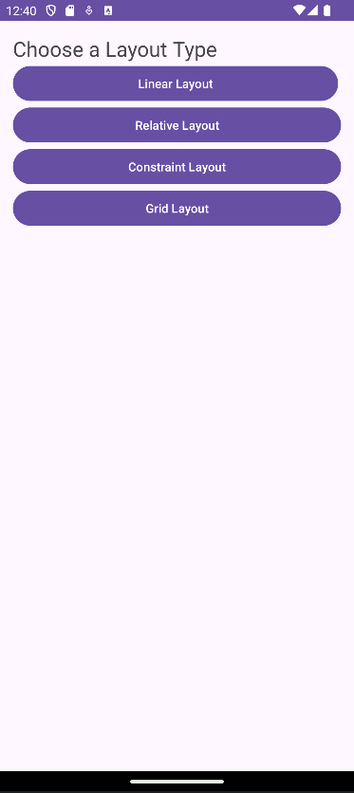 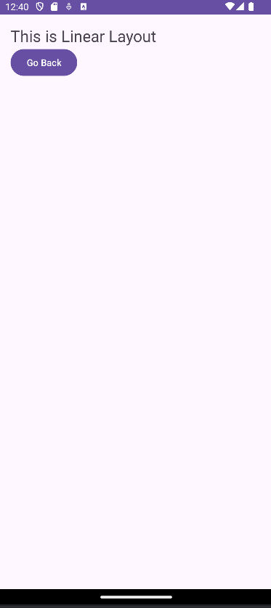 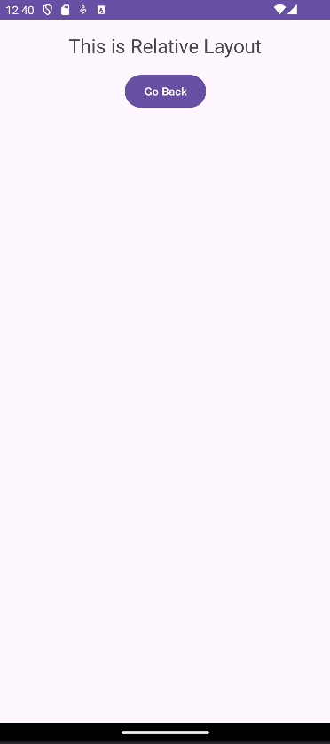

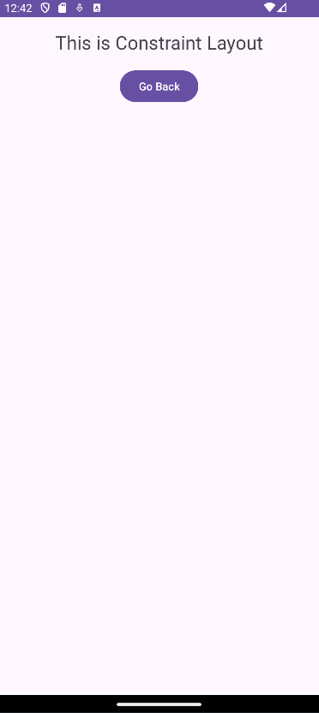 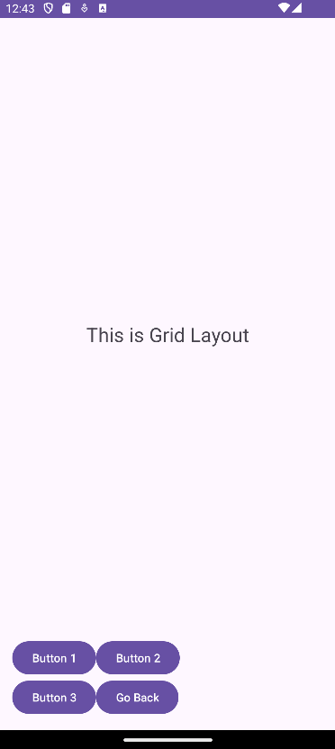

Task 2:

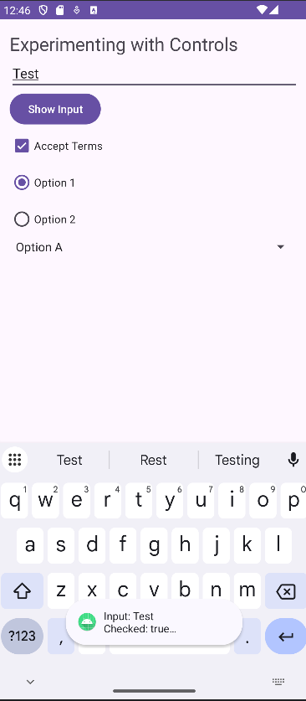

Task 3:

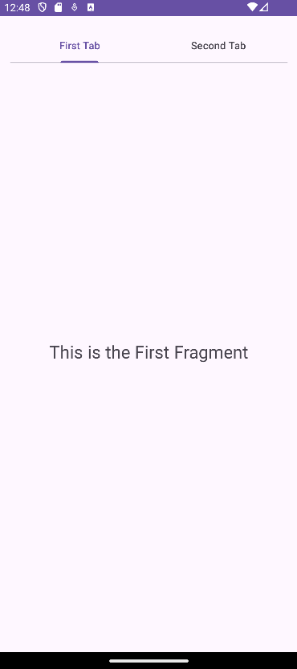 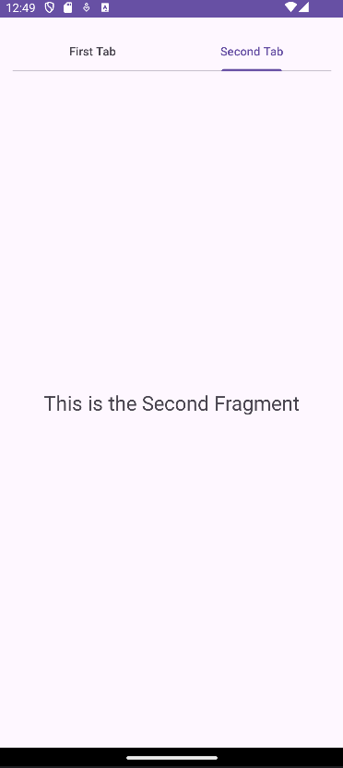

Task 4:

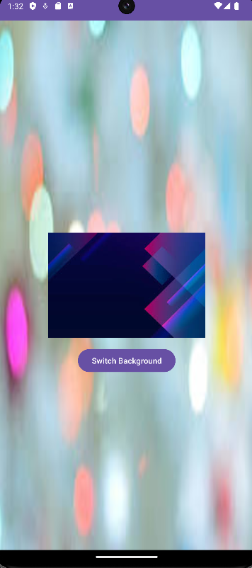 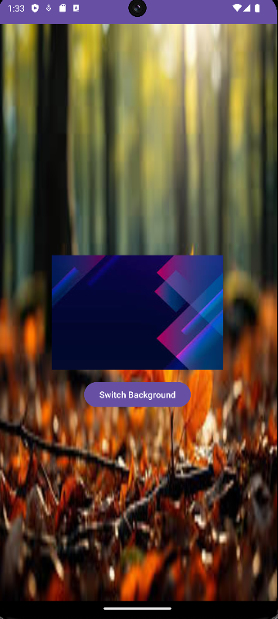

Task 5:

